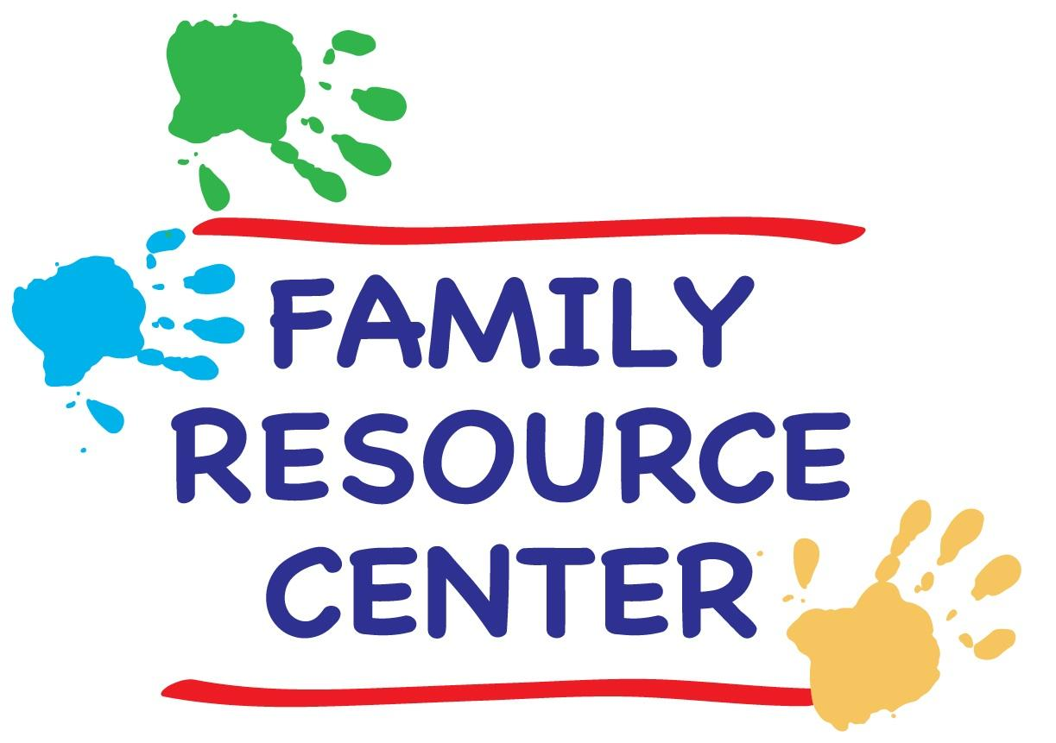University of Chicago
Family Resource Center
Autumn 2018 Schedule

SCHEDULE of CLASSES & ACTIVITIES

Family Resource Center

Location: Woodlawn Community Service Center
950 East 61st Street
Phone: 773-795-5437 (KIDS)
Hours: Monday – Friday 9:00 a.m. - 5:00 p.m.
Saturdays 10:00 a.m. – 4:00 p.m.
(Closed during University holidays and breaks).
Website: https://grad.uchicago.edu/life-at-uchicago/family-resources/
Director:Lizanne Phalen: lizannep@uchicago.edu

Weekly Classes
Messy Mat Crafts for the Very Young
Creative Ballet
Story Time Fun
Come and Count
World Music Class 10:00
World Music Class 11:00
Young Mad Scientists Unite
Fun in the Sun
Stories, ABCs & 123

Family Activities
FRC Opening Celebration Halloween Parade & Trick or Treating
Fun with Fall Leaves Graduate Student Social
Prince & Princess Party Thanksgiving Stories
Winter Holiday Party

A general registration form is required for valid class registration. Classes are first come, first served. No registrations will be accepted after Friday, October 5th, 2018.

Please note that payment is due by the end of the first week of classes (Friday, October 5th) in order to secure a position in the classes of your choice.

Partial scholarships are available to those who qualify, contact lizannep@uchicago.edu. Cash or a check (made out to UChicagoGRAD) will be accepted as payment.

WEEKLY CLASSES

MESSY MAT CRAFTS FOR THE VERY YOUNG. This crafts class will engage the very young by focusing less on creating a take-home art project, and more on exploration and play. It will introduce children to various craft mediums and textures. For instance, we will use play dough, all sorts of finger paints, and even make some edible art. This will be tactile heaven and perfect for children wanting to eat the supplies!! The class activity will likely take half an hour at most, but will be available for the entire hour.

Time: Mondays from 11:00 - 12:00 a.m. (Oct 1st – Dec 3rd).
Location: Family Resource Center Art Room
Ages: 18 months – 2 and half years old
Cost: $15 activity fee/10 classes

COME AND COUNT. This class will be focused on numbers and counting. Together we will work to identify different numbers and improve our counting skills through fun activities and art projects. Studies have shown that early math skills are grasped more quickly when children combine counting with touch. Youngsters will do activities like building towers by counting the blocks, and race-car races by counting all the different colored cars and beginner level number puzzles. We will also have fun art projects, including making numbers with finger-paint, tissue paper, and pom-poms.

Time: Mondays from 4:00 - 4:45 p.m. (Oct 1st – Dec 3rd).
Location: Family Resource Center
Ages: 2-4 years old

STORY TIME FUN. Join us for some story-time fun!! Laura has performed as a children's storyteller for 20 years, at parties, bookstores, community centers and preschools. Each story-time consists of books, finger plays and interactive songs on a theme, and finishes with dancing and marching with percussion instruments. While the stories are best suited to the target ages listed, other ages are welcome.

Time: Tuesdays 10:30 a.m. (Oct. 2nd – Dec. 4th).
Location: Family Resource Center
Ages: 2-5 years old
Cost: Free!!

CREATIVE BALLET. Put on your thinking caps and come explore creative ballet with a UChicago dancer. Young boys and girls will learn dance fundamentals such as rhythm and shape, establish a basic classical ballet vocabulary, and play creative movement games in this lively creative ballet class.

Time: Tuesdays from 4:00 - 4:45 p.m. (Oct 2nd – Dec 4th).
Location: FRC Multi - Purpose Room
Ages: 3-5 years olds
Cost: $40 per child/10 classes
COME AND COUNT. This class will be focused on numbers and counting. Together we will work to identify different numbers and improve our counting skills through fun activities and art projects. Studies have shown that early math skills are grasped more quickly when children combine counting with touch. Youngsters will do activities like building towers by counting the blocks, and race-car races by counting all the different colored cars and beginner level number puzzles. We will also have fun art projects, including making numbers with finger-paint, tissue paper, and pom-poms.

Time: Tuesdays from 3:45 - 4:30 p.m. (Oct. 2nd – Dec. 4th).
Location: Family Resource Center
Ages: 2-4 years old
Cost: $15 per child/10 classes

WORLD MUSIC FOR INFANTS & TODDLERS. Debbie Parks teaches this perennial favorite at the FRC. Expect an energetic, interactive class for parent/caregiver and child. Sing-along greeting to each child, singing stories, finger plays, lap songs, movement and dancing, rhythm instruments, and a chance to play the instructor’s instrument each week. Music includes traditional folk songs and children’s songs from all over the world. Research shows music participation is a brain booster for the young child.
Time: Wednesdays from 10:00 - 10:45 a.m. (Oct. 3rd – Dec. 5th, except 11/21).
Location: FRC Multi-Purpose Room
Ages: 6 months to 3.5 years
Cost: $50 per child/9 classes

Time: Wednesdays from 11:00 - 11:45 a.m. (Oct. 3rd – Dec. 5th, except 11/21).
Location: FRC Multi-Purpose Room
Ages: 6 months to 3.5 years
Cost: $50 per child/9 classes

YOUNG MAD SCIENTISTS UNITE. This class will allow the children to explore and experiment with the many wonders of our world. Whether it’s making play dough, building our very own volcano, or exploring the changes happening outdoors, we'll see what the kids can "cook up." No matter the adventure, fun will always be on the menu. This class will be led by FRC assistant, Laura MacGregor.

Time: Wednesdays from 3:45 - 4:30 p.m. (Oct. 3rd – Dec. 5th, except 11/21).
Location: FRC Multi-Purpose Room
Ages: 2 ½ -5 years old
Cost: $15 per child/ 9 classes

FUN IN THE SUN. Youngsters will have a chance to get out all their energy every Thursday by playing fun outdoor games and practicing the basics of beginner sports. Our activities will include animal relay races, obstacle courses, ball tag as well as games with parachutes and bubbles. We will practice throwing and kicking with different kinds of objects (balloons, beach balls, and kick balls, etc.) and learn the basic rules of beginner sports. Classes will be held outside on warm days.

Time: Thursdays from 3:45 - 4:30 p.m. (Oct. 4th – Dec. 6th, except 11/22).
Location: FRC Multi-Purpose Room and outside
Ages: 3-5 years old
Cost: Free!!

Stories, ABCs & 123. Come join us for a play-based approach to story time, early letter and number understanding. In early childhood, much of a child’s literacy and numeracy learning is gleaned from being read stories and being engaged in activities and games. We will help with letter and number recognition through crafts, songs, stories and games.

Time: Fridays 10:30 - 11:15 a.m. (Oct. 5th – Dec. 7th, except 11/23).
Location: FRC Multi-Purpose Room
Ages: 2-4 years old
Cost: $15 per child/10 classes

FAMILY ACTIVITIES

All activities are free to registered members and will take place at the Family Resource Center unless otherwise noted. Children must be accompanied by parents or by designated caregivers.

OPENING CELEBRATION! Thursday, Sept. 27th, 3:00 p.m. A welcome to friends new and old. Our favorite teacher, Debbie Parks, will entertain and help us celebrate the re-opening of the FRC. Appropriate for children of all ages! Light refreshments will be provided. Debbie is our World Music teacher so come participate in a demonstration of the class and sign up – it begins the following Wednesday and is open to children 6 months and up!

FUN WITH FALL LEAVES. Monday, Oct. 15th, 4:00 - 4:45. Come and celebrate the magic of the turning season with crafts, snacks and stories about autumn leaves.

HALLOWEEN PARADE & TRICK-OR-TREATING. Wednesday, October 31st, 3:00 - 4:30 p.m. at the FRC. Join us to decorate treat bags and pumpkins. Then, we will parade across campus to different campus offices for “trick or treating.” Wear your Halloween costume! Children of all ages welcome.

GRADUATE STUDENT PARENT SOCIAL. Saturday, Nov. 3rd, 4:00 – 6:00 p.m. Come mix and mingle with fellow graduate student and postdoc parents and enjoy complimentary wine and cheese. Now you have no excuse to skip date-night! RSVP is required. Free parking available behind the WSSC and children are welcome.

PRINCE AND PRINCESS PARTY. Thursday, Nov. 15th, 3:30-4:30 p.m. Attending princes and princesses will dress the part, make jeweled crowns, eat fancy finger food and dance!

THANKSGIVING STORIES. Tuesday, Nov. 20th, 10:30-11:30 a.m. Get in the spirit for the Thanksgiving holiday weekend with songs and stories, including the story of the 1st Thanksgiving. Then join us in making a simple craft and eating some delicious pumpkin pie.

WINTER HOLIDAY PARTY. Friday, December 6th, 3:30 - 4:30 p.m. at the FRC. Entertainment, games, light snacks!

PLAYGROUP

GERMAN PLAYGROUP. This playgroup used to meet at the FRC but is now organized by native German and German speaking parents based in Hyde Park, who want their children to play and have fun with other German-speaking children. Currently our children are between 0 and 11 years old. This group meets weekly in members' homes to sing and chat, exchange information and simply enjoy each other’s company. Please contact Stephanie muestx@gmail.com if you are interested in participating.

