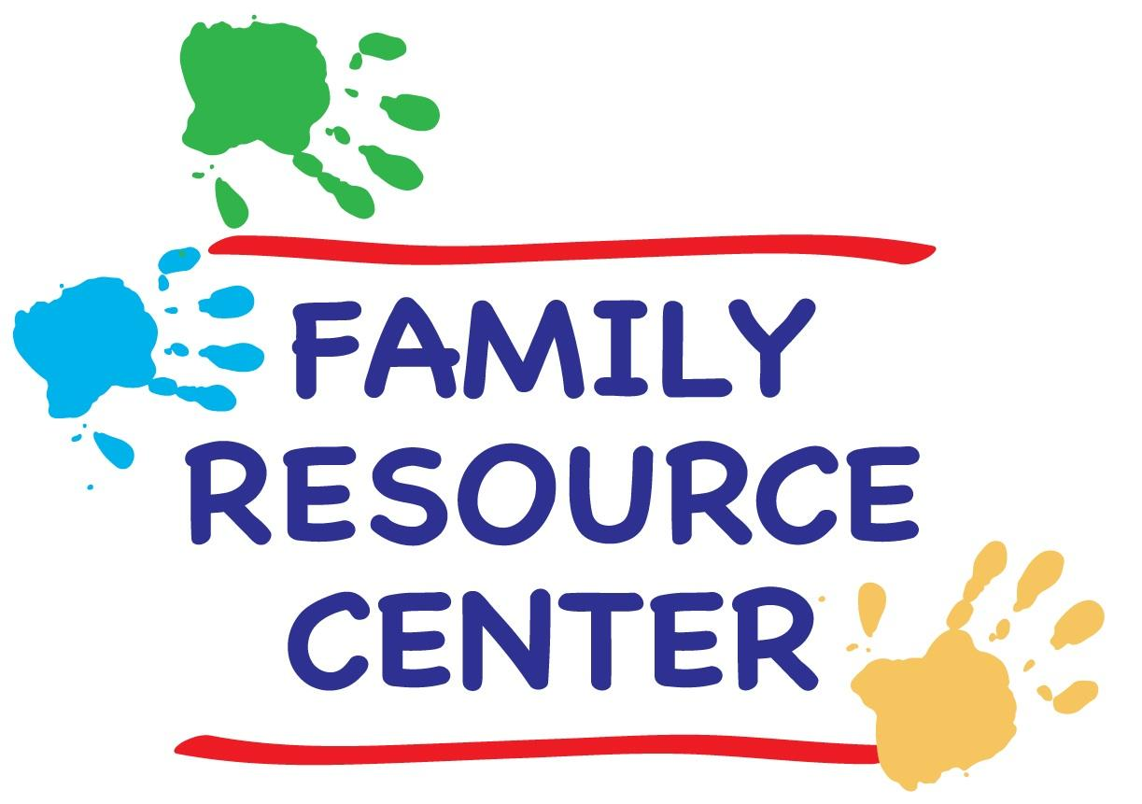University of Chicago
Family Resource Center
Winter 2019 Schedule

SCHEDULE of CLASSES & ACTIVITIES

Family Resource Center

Location: Woodlawn Community Service Center
950 East 61st Street
Phone: 773-795-5437 (KIDS)
Hours: Monday – Friday 9:00 a.m. - 5:00 p.m.
Saturdays 10:00 a.m. – 4:00 p.m.
(Closed during University holidays and breaks).
Website: https://grad.uchicago.edu/life-at-uchicago/family-resources/
Director:Lizanne Phalen: lizannep@uchicago.edu

Weekly Classes
Messy Mat Crafts for the Very Young
Creative Ballet
Story Time Fun
World Travelers
World Music Class 10:30
Young Mad Scientists Unite
Alphabet Soup
Movin’ to the Music

Family Activities
Fun with Thomas
Asian New Year Story-Hour
Valentine, My Valentine!
Student/Postdoc Social
Spring Rummage Exchange
End of Quarter Party

A general FRC form (Consent & Release) is required for valid class registration. Classes are first come, first served. No registrations will be accepted after Friday, January 11th.

Please note that payment is due by the end of the first week of classes (Friday, January 11th) in order to secure a position in the classes of your choice.

Partial scholarships are available to those who qualify, contact lizannep@uchicago.edu. Cash or a check (made out to UChicagoGRAD) will be accepted as payment.

WEEKLY CLASSES

MESSY MAT CRAFTS FOR THE VERY YOUNG. This crafts class will engage the very young by focusing less on creating a take-home art project, and more on exploration and play. It will introduce children to various craft mediums and textures. For instance, we will use play dough, all sorts of finger paints, and even make some edible art. This will be tactile heaven and perfect for children wanting to eat the supplies!! The class activity will likely take half an hour at most, but will be available for the entire hour. Interested older kids are welcome.

Time: Mondays from 10:30-11:30 a.m. (Jan 7-Mar 11, except 1/21).
Location: Family Resource Center Art Room
Ages: 18 months – 2 and half years old
Cost: $15 activity fee/9 classes

WORLD TRAVELERS. Each week we'll "travel" to a different country, and stamp our special passports. Listening to songs, looking at photos, reading stories, watching short videos, and making crafts, we’ll learn about different cultures and traditions. Each class will end with an announcement about what country we'll visit next week, and students are encouraged to bring items to show and tell about nations with which they have a special connection.

Time: Mondays from 4:00-4:45. (Jan 7-Mar 11, except 1/21).
Location: FRC Multi-Purpose Room
Ages: 2-4 years old
Cost: $15 activity fee/9 classes

STORY TIME FUN. Join us for some story-time fun!! Laura has performed as a children's storyteller for 20+ years, at parties, bookstores, community centers and preschools. Each story-time consists of books, finger plays and interactive songs on a theme, and finishes with dancing and marching with percussion instruments. While the stories are best suited to the target ages listed, other ages are welcome.

Time: Tuesdays 10:30 a.m. (Jan 8-Mar 12).
Location: Family Resource Center
Ages: 2-5 years old
Cost: Free!!

CREATIVE BALLET. Put on your thinking caps and come explore creative ballet with a UChicago dancer. Young boys and girls will learn dance fundamentals such as rhythm and shape, establish a basic classical ballet vocabulary, and play creative movement games in this lively creative ballet class.

Time: Tuesdays from 4:00 - 4:45 p.m. (Jan 8-Mar 12).

Location: FRC Multi - Purpose Room
Ages: 3-5 years olds
Cost: $40 per child/10 classes

WORLD MUSIC FOR INFANTS & TODDLERS. Debbie Parks teaches this perennial favorite at the FRC. Expect an energetic, interactive class for parent/caregiver and child. Sing-along greeting to each child, singing stories, finger plays, lap songs, movement and dancing, rhythm instruments, and a chance to play the instructor’s instrument each week. Music includes traditional folk songs and children’s songs from all over the world. Research shows music participation is a brain booster for the young child.
Time: Wednesdays from 10:00 - 10:45 a.m. (Jan 9-Mar 13).
Location: FRC Multi-Purpose Room
Ages: 6 months to 3.5 years
Cost: $50 per child/10 classes

Time: Wednesdays from 11:00 - 11:45 a.m. (Jan 9-Mar 13).
Location: FRC Multi-Purpose Room
Ages: 6 months to 3.5 years
Cost: $50 per child/10 classes

YOUNG MAD SCIENTISTS UNITE. This class will allow the children to explore and experiment with the many wonders of our world. Whether it’s making play dough, building our very own volcano, or exploring the changes happening outdoors, we'll see what the kids can "cook up." No matter the adventure, fun will always be on the menu. This class will be led by FRC assistant, Laura MacGregor.

Time: Wednesdays from 3:45 - 4:30 p.m. (Jan 9-Mar 13).
Location: FRC Multi-Purpose Room
Ages: 2 ½ -6 years old
Cost: $15 per child/ 10 classes

ABCs & 123. Come join us for a play-based approach to story time, early letter and number understanding. In early childhood, much of a child’s literacy and numeracy learning is gleaned from being read stories and being engaged in activities and games. We will help with letter and number recognition through crafts, songs, stories and games.

Time: Thursdays 10:30 - 11:15 a.m. (Jan 10-Mar 14).
Location: FRC Multi-Purpose Room
Ages: 2-4 years old
Cost: $15 per child/ 10 classes

MOVIN’ TO THE MUSIC. In this fun movement class, we will move to favorite children’s CD’s, while playing with collapsible tunnels, hippity hop balls, parachutes and scarves. This is a great opportunity to shake off the winter blahs, and run dance or bounce around. The activity should be fun for all ages.

Time: Fridays from 3:150-4:00 p.m. (Jan. 11th -March 15th).
Location: FRC Multi-Purpose Room
Age: 2-4 years old
Cost: Free!!

Calendar of Family Activities

Registration for each event will take place a few days before the activity, and will be announced via email on the Student Parent listserv. Descriptions and dates are for planning purposes.

All activities are free to registered members and will take place at the Family Resource Center. Children must be accompanied by parents or by designated caregivers.

FUN WITH THOMAS. Wednesday, January 16th 3:45-4:30. Come play with everyone’s favorite engine! We’ll get out all our Thomas the Tank Engine Toys, do a train craft, and have a sweet treat.

CHINESE NEW YEAR STORYHOUR. Tuesday, February 5th, 10:30-11:30 a.m. Come celebrate the Year of the Pig with stories about the holiday--and about the honored animal! After a couple of stories and songs, we will make a simple craft, snack on special sweets, and take home traditional red envelopes with a surprise inside.

VALENTINE, MY VALENTINE. Thursday, February 14th, 3:45 - 4:30 p.m. Encourage your children to show their love for the special people in their lives by making valentines. We will also decorate cookies or cupcakes, and play Conversation Heart Bingo!

GRADUATE STUDENT PARENT SOCIAL. Saturday, February 16th, 4:00 – 6:00 p.m. Did you manage to have a romantic dinner with your partner this Valentine’s Day? If not, bring the kids along on a date at the FRC. Come mix and mingle with fellow graduate student and postdoc parents and enjoy complimentary wine and cheese. RSVP is required. Free parking available behind the WSSC and children are welcome.

SPRING CLEAN-UP RUMMAGE EXCHANGE. Wednesday & Thursday, March 6th & 7th, all day. Remember, your trash might be somebody else’s treasure! Bring clean, gently used children’s clothing and toys, and get some to take home.

END OF WINTER PARTY. Friday, March 22nd, 3:00 - 4:30 p.m. All are welcome at this end-of-quarter celebration featuring games, crafts. Light refreshments will be provided and children of all ages are welcome. Come bid farewell to winter with food and fun.

PLAYGROUP

GERMAN PLAYGROUP. This playgroup used to meet at the FRC but is now organized by native German and German speaking parents based in Hyde Park, who want their children to play and have fun with other German-speaking children. Currently our children are between 0 and 11 years old. This group meets weekly in members' homes to sing and chat, exchange information and simply enjoy each other’s company. Please contact Stephanie muestx@gmail.com if you are interested in participating.

