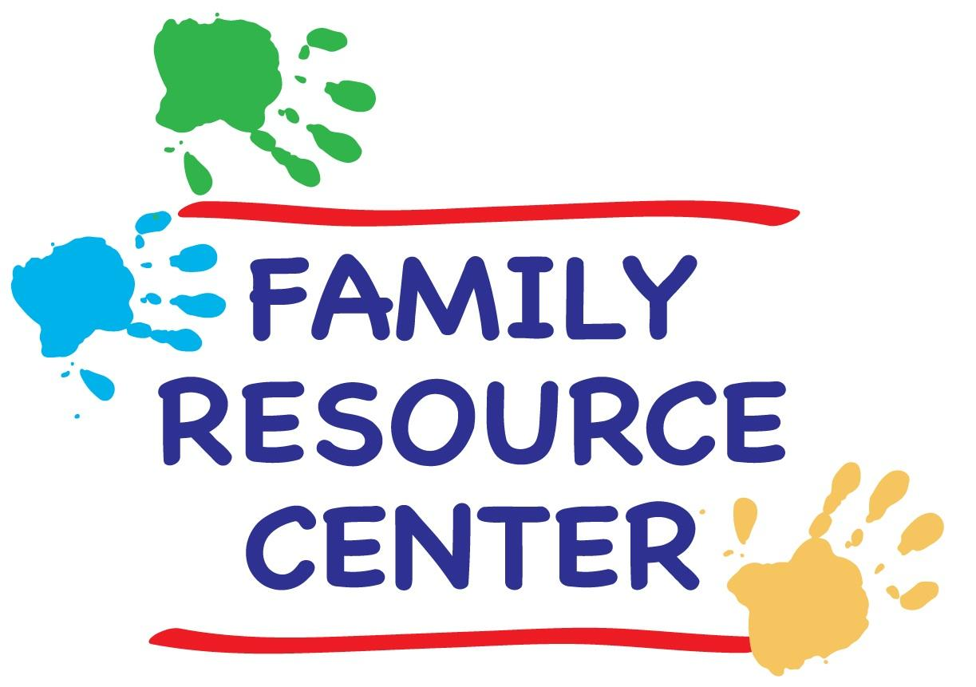University of Chicago
Family Resource Center
Spring 2019 Schedule

SCHEDULE of CLASSES & ACTIVITIES

Family Resource Center

Location: Woodlawn Community Service Center
950 East 61st Street
Phone: 773-795-5437 (KIDS)
Hours: Monday – Friday 9:00 a.m. - 5:00 p.m.
Saturdays 10:00 a.m. – 4:00 p.m.
Summer: Monday-Friday, 10-4
(Closed during University holidays and breaks). Website: FRC

Director: Lizanne Phalen, lizannep@uchicago.edu

Weekly Classes
Messy Mat Crafts for the Very Young
Things That Go
Story Time Fun
Creative Ballet
World Music Class
Nature Explorers Science
Alphabet Soup
Learning with Arts & Crafts
Movin’ to the Music

Family Activities

INCREDIBLE, EDIBLE EGG, 4/19
EARTH DAY STORY HOUR, 4/23
GRADUATE STUDENT and POSTDOC PARENT SOCIAL, 5/3
SURPRISE MOM ON MOTHER’S DAY, 5/10
SPRING RUMMAGE SALE, 5/15 & 16 UNBIRTHDAY PARTY, 6/3 SPRING CARNIVAL—6/15

Please fill out the form here to register for spring quarter FRC classes. Registration page is open until Sunday 4/7, but late registration may be possible with instructor permission.

All families registering for FRC activities must be FRC members. All student parents signing up for write in sessions must also have an active FRC membership.

WEEKLY CLASSES

MESSY MAT CRAFTS FOR THE VERY YOUNG. This crafts class will engage the very young by focusing less on creating a take-home art project, and more on exploration and play. It will introduce children to various craft mediums and textures. For instance, we will use play dough, all sorts of finger paints, and even make some edible art. This will be tactile heaven and perfect for children wanting to eat the supplies!! The class activity will likely take half an hour at most, but will be available for the entire hour.

Time: Mondays from 10:30-11:30 a.m. (April 8th-June 10th, except May 27).
Location: Family Resource Center Art Room
Ages: 18 months – 2 and half years old
Cost: $15 per child/9 classes

THINGS THAT GO. Have a child who loves everything on wheels? Come play with Laura and explore planes, trains and automobiles (along with boats, busses and bikes) through creative crafts, stories and games devoted to things that GO!!

Time: Mondays from 4:00-4:45 p.m. (April 8th-June 10th, except May 27).
Location: FRC Multi-Purpose Room
Ages: 2-6
Cost: $15 per child/10 classes

STORY TIME FUN. Join us for some story-time fun!! Laura has performed as a children's storyteller for 20 years, at parties, bookstores, community centers and preschools. Each story-time consists of books, finger plays and interactive songs on a theme, and finishes with dancing and marching with percussion instruments. While the stories are best suited to the target ages listed, other ages are welcome.

Time: Tuesdays at 10:30 a.m. (April 9th – June 11th).
Location: Family Resource Center
Ages: 2-5 years old
Cost: Free!!

CREATIVE BALLET. Put on your thinking caps and come explore creative ballet with our UChicago Ballet dancer/instructor. Young boys and girls will learn dance fundamentals such as rhythm and shape, establish a basic classical ballet vocabulary, and play creative movement games in this lively creative ballet class.

Time: Tuesdays from 4:00 - 4:45 p.m. (April 9th-June 11th).
Location: FRC Multi-Purpose Room
Ages: 3-5 years old
Cost: $40 per child/10 classes

WORLD MUSIC FOR INFANTS & TODDLERS. Debbie Parks teaches this perennial favorite at the FRC. Expect an energetic, interactive class for parent/caregiver and child. Sing-along greeting to each child, singing stories, finger plays, lap songs, movement and dancing, rhythm instruments, and a chance to play the instructor’s instrument each week. Music includes traditional folk songs and children’s songs from all over the world. Research shows music participation is a brain booster for the young child.

Time: Wednesdays from 10:30-11:15 a.m. (April 10th-June 12th).
Location: FRC Multi-Purpose Room
Ages: 6 months to 3.5 years
Cost: $50 per child/10 classes

NATURE EXPLORER’S SCIENCE. After a long winter of being cooped up, come celebrate spring with us! Class will focus on the science of weather and nature we can observe outside. Once the weather allows, we will venture out to explore, collect things or play. Depending on the lesson, the class may include stories, crafts, experiments, songs or games. Activities will include planting projects and watching our own caterpillars as they build cocoons and fly away as butterflies.

Time: Wednesdays, 4:00-4:45 p.m. (April 10th-June 12th)
Location: Various (meet in the FRC Story area)
Ages: 2-6
Cost: $15 per child/10 classes

ALPHABET SOUP. Come join us for a play-based approach to story time, early letter and number understanding. In early childhood, much of a child’s literacy and numeracy learning is gleaned from being read stories and being engaged in activities and games. We will help with letter and number recognition through crafts, songs, stories and games.

Time: Thursdays, 10:30 - 11:15 a.m. (April 11th-June 13th)
Location: FRC Multi-Purpose Room
Ages: 2-5 years old
Cost: $15 per child/10 classes

LEARNING WITH ARTS AND CRAFTS. Children will learn about different subjects each week (color, shape, nature, animals, music, etc) explore their creativity with a related craft. We will introduce a little bit about each theme and then make art with various materials. The project will be collected, and at the end of the quarter, we will put each child's art together into a keepsake booklet.

Time: Thursdays 3:45 - 4:30 p.m. (April 11th-June 13th)
Location: FRC Multi-Purpose Room
Ages: 2-6 years old
Cost: Free!!

MOVIN TO THE MUSIC In this fun movement class, we will move to favorite children’s music while doing movement activities such as dancing or playing with tunnels, balls, parachutes and scarves. This is a great opportunity to shake off the winter blahs, and run, dance or bounce around. Fun for all ages.

Time: Fridays 10:30-11:15 a.m. (April 12th-June 13th).
Location: FRC Multi-Purpose Room
Ages: All Ages
Cost: Free!!

Calendar of Family Activities
Registration for each event will take place 1 week before the activity, and will be announced via email on the Student Parent listserv. Descriptions and dates are for planning purposes.

All activities are free to registered members and will take place at the Family Resource Center. Children must be accompanied by parents or by designated caregivers.

THE INCREDIBLE, EDIBLE EGG. Friday, April 19, 3:45-4:30 p.m. In anticipation of Easter and springtime, join us for egg decorating fun!

EARTH DAY STORY HOUR. Tuesday, April 23rd, 10:30-11:30 a.m. Join us for Earth Day stories and songs with a special craft and snacks, to help teach your child about being a good steward to planet earth.

GRADUATE STUDENT PARENT SOCIAL. Saturday, May 3rd, 4:00 – 6:00 p.m. Come mix and mingle with fellow graduate student and postdoc parents and enjoy complimentary wine and cheese. RSVP is required. Free parking available behind the WSSC and children, of course, are welcome!

SURPRISE MOM ON MOTHER’S DAY. Friday, May 10th, 3:45-4:30 p.m.
FRC staff will work with children to create a surprise Mother’s Day treat. The treasures they create will be wrapped and kept a surprise (if they can) until Mother’s Day.

SPRING CLEAN-UP RUMMAGE EXCHANGE. Wednesday & Thursday, May 14th & 15th, all day. Remember, your trash might be somebody else’s treasure! Bring clean, gently used household and family items, and get some to take home.

UNBIRTHDAY PARTY. Monday, June 3, 3:45-4:30 p.m. It’s so very hard to wait a whole year between birthdays. Come celebrate with everyone else who doesn’t have a birthday today! Birthday cake, balloons and an un-birthday song are on the menu.

SPRING CARNIVAL- END OF THE YEAR CELEBRATION. Friday, June 14th, 3:00-4:30 p.m. All are welcome at this end-of-quarter party featuring games, crafts, and much more fun. Light refreshments will be provided and children of all ages are welcome.

